Commence Guide Version 1.0

Tested Using: EasyPHP 1.8
Commence Version: 1-1a
Apache Server Version: 1.3.33
PHP Version: 4.3.10
MySQL Version: 4.1.9
PhpMyAdmin Version: 2.6.1

Last Revision:
Author: Valerie Pooh

This guide may not work with other EasyPHP, Apache Server, Commence, MySQL and PhpMyAdmin versions.

Content | Page(s)
- Download Commence | 3-4
- Recommended Software to Download | 5-6
- Where to extract the Commence folder? | 7
- Changes to be Made Before Running Commence | 8
- Start Using Commence | 9-12
- Appendix A | 13-24

- Download Commence

  - You can download the latest release of Commence but this guide was tested using Commence Version 1-1a.

  - Go to this web site, http://sourceforge.net/projects/iaprcommence/, scroll down the page and download.

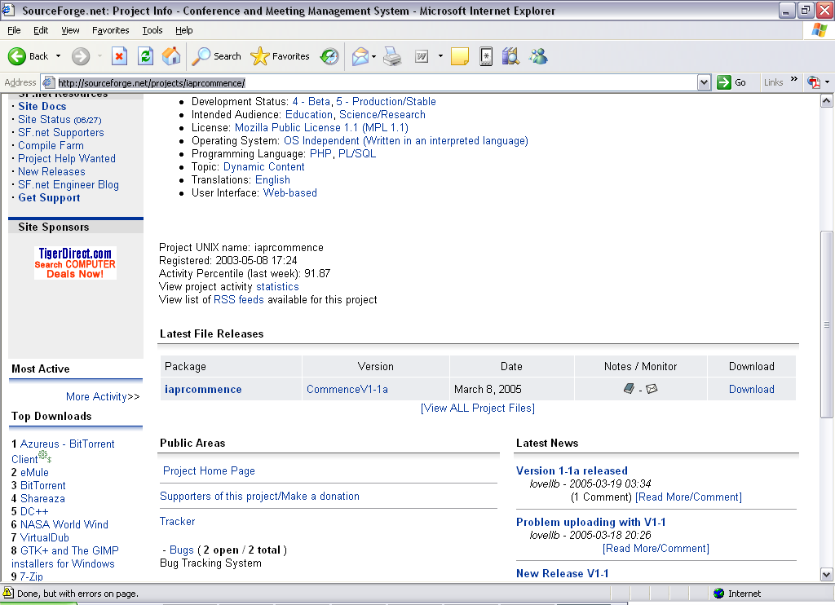

  - Click on the link that has a “.zip” extension.
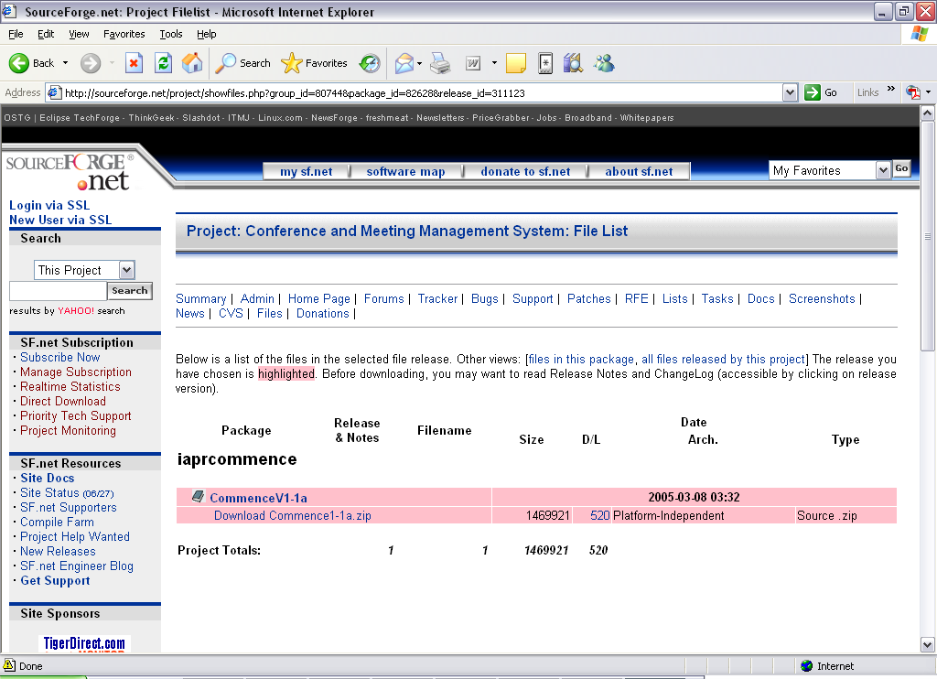

  - Select the host that is the nearest to your current location for faster downloading speed. And click the icon under the “Download” column to start downloading.

- Recommended Software to Download

  - Before we extract the Commence folder, I recommend that you install EasyPHP 1.8 which also installs PHP, Apache Server and MySQL.

  - Go to http://www.easyphp.org/telechargements.php3 and download EasyPHP 1.8 as this version was tested with Commence Version 1-1a.

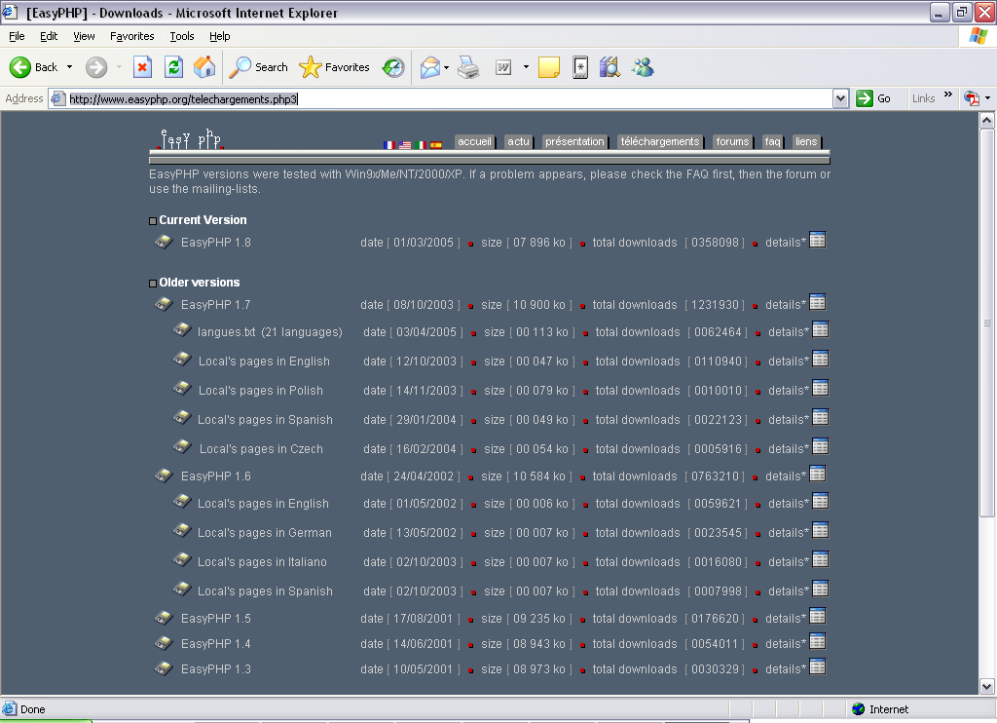

  - Choose the host that is the nearest to your current location and download the file.

  - For more information on how to install and use EasyPHP 1.8, please go to www.aaa.com to download and read that before you continue with this guide.

- Where to extract the Commence folder?

  - After you have downloaded the file, please unzip and extract everything to the document root of your Apache server. You will see a folder named “Commence1-1a” after you have extracted everything successfully.

  - If you are not sure where the document root of your Apache server is, please follow the next few instructions.

    - Search for “httpd.conf” file at the directory where your Apache Server is installed.

    - If you are using EasyPHP, click on icon> Configuration> Apache to open “httpd.conf” file.

    - Search for “DocumentRoot” variable inside the “httpd.conf” file and it will state where the document root is.

- Changes to be Made Before Running Commence

  - Open “php.ini” file and search for “allow_call_time_pass_reference=Off”. Change “Off” to “On” to remove the error messages such as:

“Warning: Call-time pass-by-reference has been deprecated - argument passed by value; If you would like to pass it by reference, modify the declaration of [runtime function name](). If you would like to enable call-time pass-by-reference, you can set allow_call_time_pass_reference to true in your INI file. However, future versions may not support this any longer in c:\program files\easyphp1-8\www\commence1-1a\install\install.php on line 22”.

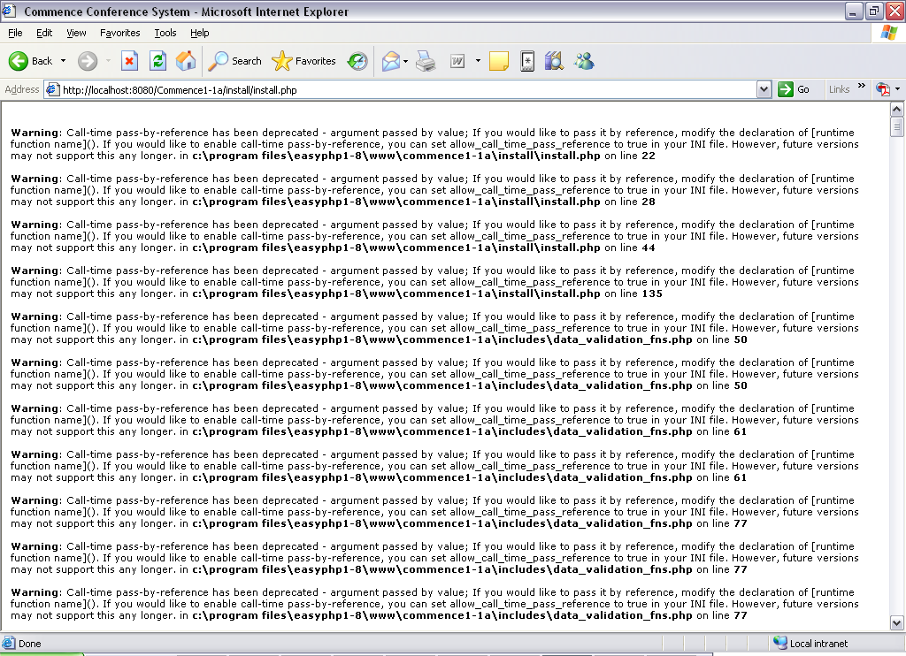

  - Search for “error_reporting”. Please change this line, “error_reporting = E_ALL” to “error_reporting = E_ALL & ~E_NOTICE” to remove error messages such as:

“Warning: Cannot modify header information - headers already sent by (output started at c:\program files\easyphp1-8\www\commence1-1a\install\install.php:10) in c:\program files\easyphp1-8\www\commence1-1a\includes\page_includes\page.php on line 14”
  - Once these changes have been made, you should not see any error messages when you run “install.php”, which we will discuss next. If you still see error messages, please double-check if you have made all the necessary changes.
- Start Using Commence

  - Please run the “install.php” from your web space or your local machine by using a web browser to access.

  - If you are using a hosting site on the internet, you may access “install.php” by entering a similar URL like this: “www.yourwebsite.com/Commence/install/install.php”.

  - If you are using a local machine to access the web page, please type in a similar URL like this: “http://localhost/Commence1-1a%5C/install/install.php”.

  - You should be seeing a similar interface as shown in the screenshot below.
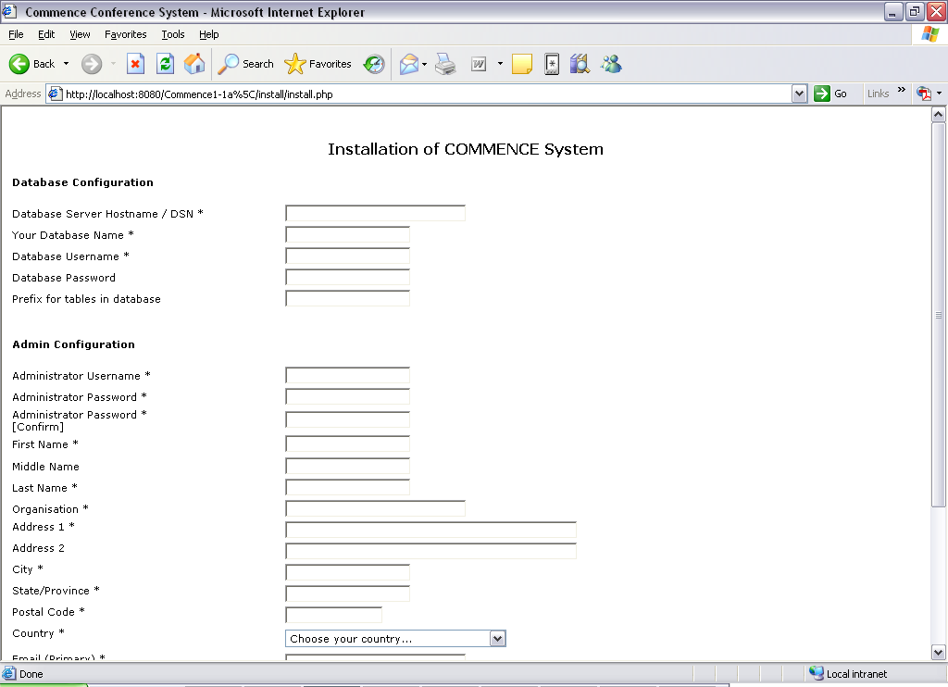

  - After you have filled in all the necessary fields, you will be directed to this page, if your server does not have permission to write to the file “preferences.php”.

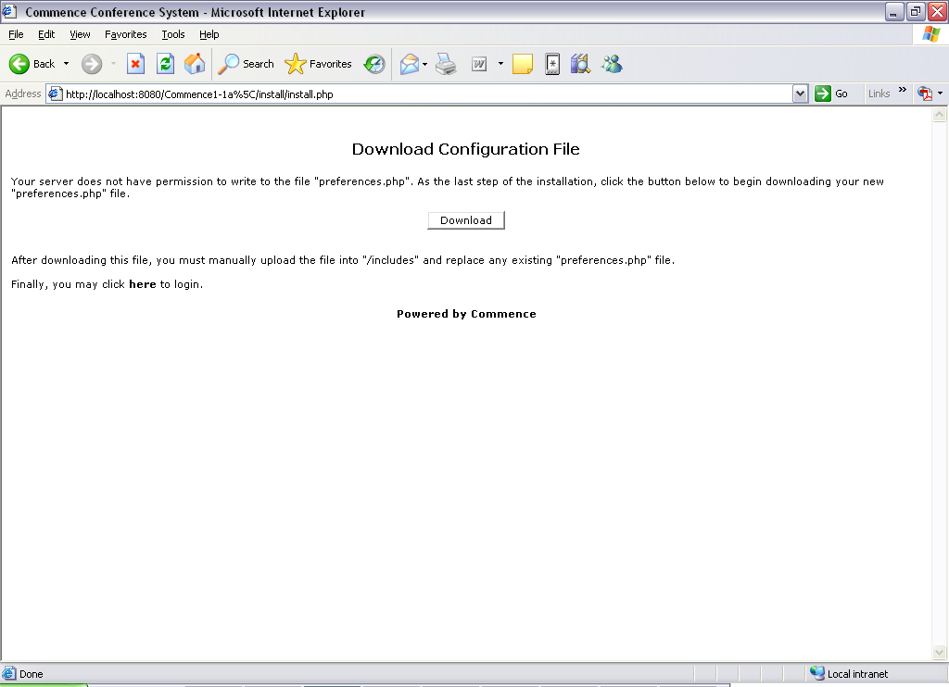

  - And so we will have to download and manually upload the file, “preferences.php”, into “ApacheDocumentRoot\Commence1-1a\includes”.

  - After you have done that, you can go to “http://localhost/Commence1-1a%5C/index.php” on your local machine or go to “http://www.yourwebspace.com/Commence1-1a%5C/index.php” on your hosting site to login and start using Commence.

  - After a successful login, you will need to fill in more details about your Conference.

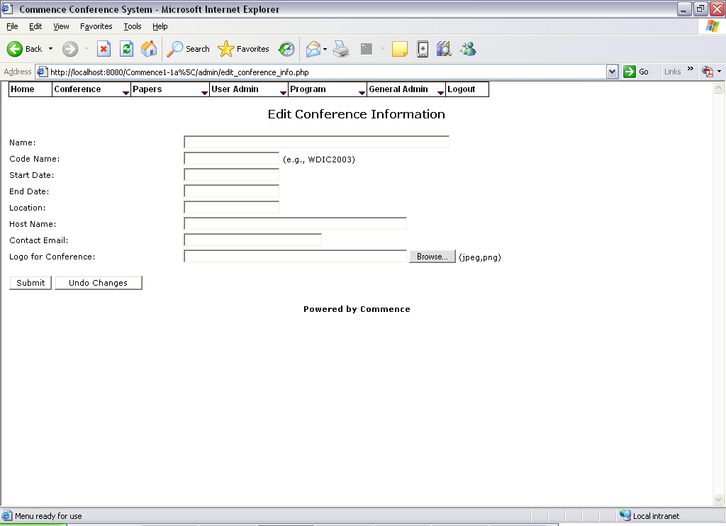

  - After you have filled all the necessary information as prompted, you will be seeing a similar screen as shown below.

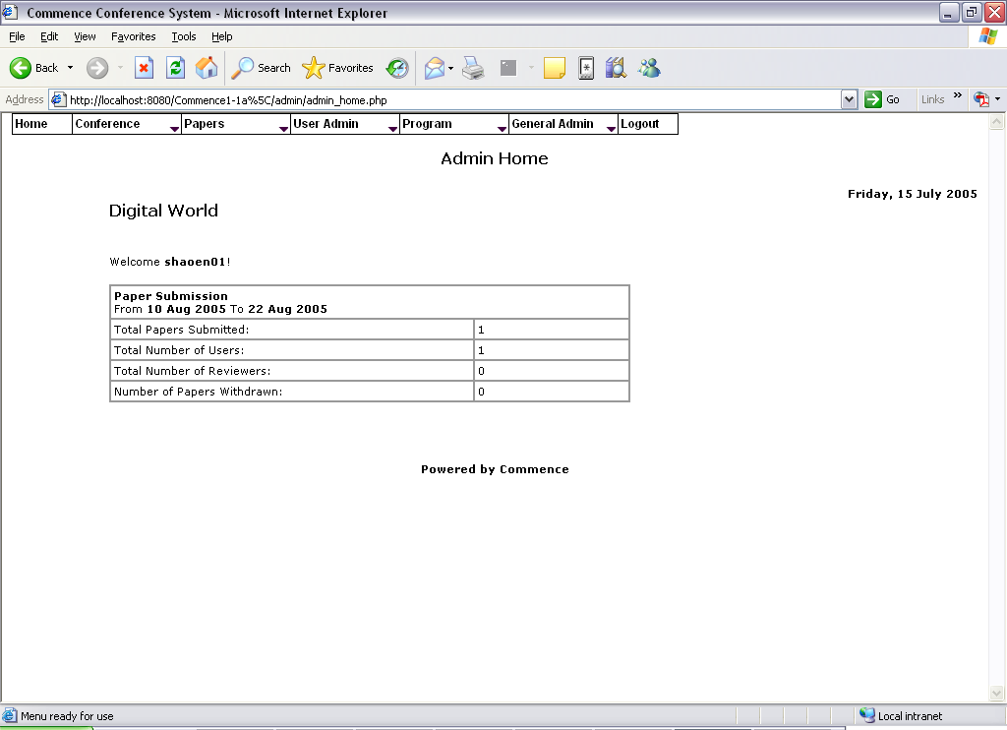

- Appendix A



PHP Version 4.3.10

System | Windows NT YOUR-EQ2IJUFCWT 5.1 build 2600
Build Date | Dec 14 2004 17:46:48
Server API | Apache
Virtual Directory Support | enabled
Configuration File (php.ini) Path | c:\program files\easyphp1-8\apache\php.ini
PHP API | 20020918
PHP Extension | 20020429
Zend Extension | 20021010
Debug Build | no
Thread Safety | enabled
Registered PHP Streams | php, http, ftp, compress.zlib

This program makes use of the Zend Scripting Language Engine:
Zend Engine v1.3.0, Copyright (c) 1998-2004 Zend Technologies

PHP Credits

Configuration

PHP Core
Directive | Local Value | Master Value
allow_call_time_pass_reference | On | On
allow_url_fopen | On | On
always_populate_raw_post_data | Off | Off
arg_separator.input | & | &
arg_separator.output | & | &
asp_tags | Off | Off
auto_append_file | no value | no value
auto_prepend_file | no value | no value
browscap | no value | no value
default_charset | no value | no value
default_mimetype | text/html | text/html
define_syslog_variables | Off | Off
disable_classes | no value | no value
disable_functions | no value | no value
display_errors | On | On
display_startup_errors | Off | Off
doc_root | no value | no value
docref_ext | no value | no value
docref_root | no value | no value
enable_dl | On | On
error_append_string | no value | no value
error_log | no value | no value
error_prepend_string | no value | no value
error_reporting | 2039 | 2039
expose_php | On | On
extension_dir | C:\PROGRA~1\EASYPH~1\\php\extensions\ | C:\PROGRA~1\EASYPH~1\\php\extensions\
file_uploads | On | On
gpc_order | GPC | GPC
highlight.bg | #FFFFFF | #FFFFFF
highlight.comment | #FF8000 | #FF8000
highlight.default | #0000BB | #0000BB
highlight.html | #000000 | #000000
highlight.keyword | #007700 | #007700
highlight.string | #DD0000 | #DD0000
html_errors | On | On
ignore_repeated_errors | Off | Off
ignore_repeated_source | Off | Off
ignore_user_abort | Off | Off
implicit_flush | Off | Off
include_path | .;C:\PROGRA~1\EASYPH~1\\php\pear\ | .;C:\PROGRA~1\EASYPH~1\\php\pear\
log_errors | On | On
log_errors_max_len | 1024 | 1024
magic_quotes_gpc | Off | Off
magic_quotes_runtime | Off | Off
magic_quotes_sybase | Off | Off
max_execution_time | 30 | 30
max_input_time | 60 | 60
open_basedir | no value | no value
output_buffering | 0 | 0
output_handler | no value | no value
post_max_size | 8M | 8M
precision | 14 | 14
register_argc_argv | Off | Off
register_globals | Off | Off
report_memleaks | On | On
safe_mode | Off | Off
safe_mode_exec_dir | no value | no value
safe_mode_gid | Off | Off
safe_mode_include_dir | no value | no value
sendmail_from | me@localhost.com | me@localhost.com
sendmail_path | no value | no value
serialize_precision | 100 | 100
short_open_tag | On | On
SMTP | localhost | localhost
smtp_port | 25 | 25
sql.safe_mode | Off | Off
track_errors | Off | Off
unserialize_callback_func | no value | no value
upload_max_filesize | 2M | 2M
upload_tmp_dir | C:\PROGRA~1\EASYPH~1\\tmp\ | C:\PROGRA~1\EASYPH~1\\tmp\
user_dir | no value | no value
variables_order | GPCS | GPCS
xmlrpc_error_number | 0 | 0
xmlrpc_errors | Off | Off
y2k_compliance | On | On

Apache
Apache for Windows 95/NT

Apache Version | Apache/1.3.33 (Win32) PHP/4.3.10
Apache Release | 10324100
Apache API Version | 19990320
Hostname:Port | localhost:8080
Timeouts | Connection: 300 - Keep-Alive: 15

Directive | Local Value | Master Value
child_terminate | 0 | 0
engine | 1 | 1
last_modified | 0 | 0
xbithack | 0 | 0

Apache Environment
Variable | Value
COMSPEC | C:\WINDOWS\system32\cmd.exe
DOCUMENT_ROOT | c:/program files/easyphp1-8/www
HTTP_ACCEPT | image/gif, image/x-xbitmap, image/jpeg, image/pjpeg, application/x-shockwave-flash, application/vnd.ms-excel, application/vnd.ms-powerpoint, application/msword, */*
HTTP_ACCEPT_ENCODING | gzip, deflate
HTTP_ACCEPT_LANGUAGE | en-us
HTTP_CONNECTION | Keep-Alive
HTTP_HOST | localhost:8080
HTTP_USER_AGENT | Mozilla/4.0 (compatible; MSIE 6.0; Windows NT 5.1; SV1; .NET CLR 1.1.4322)
PATH | C:\WINDOWS\system32;C:\WINDOWS;C:\WINDOWS\System32\Wbem;C:\Program Files\ATI Technologies\ATI Control Panel;C:\Program Files\Rational\common;C:\Program Files\Microsoft SQL Server\80\Tools\BINN;C:\PROGRA~1\EASYPH~1\Apache;C:\PROGRA~1\EASYPH~1\PHP
REMOTE_ADDR | 127.0.0.1
REMOTE_PORT | 2373
SCRIPT_FILENAME | c:/program files/easyphp1-8/www/commence1-1a//phpinfo.php
SERVER_ADDR | 127.0.0.1
SERVER_ADMIN | admin@localhost
SERVER_NAME | localhost
SERVER_PORT | 80
SERVER_SIGNATURE | <ADDRESS>Apache/1.3.33 Server at <A HREF="mailto:admin@localhost">localhost</A> Port 8080</ADDRESS>
SERVER_SOFTWARE | Apache/1.3.33 (Win32) PHP/4.3.10
SystemRoot | C:\WINDOWS
WINDIR | C:\WINDOWS
GATEWAY_INTERFACE | CGI/1.1
SERVER_PROTOCOL | HTTP/1.1
REQUEST_METHOD | GET
QUERY_STRING | no value
REQUEST_URI | /Commence1-1a%5C/phpinfo.php
SCRIPT_NAME | /Commence1-1a\/phpinfo.php

HTTP Headers Information
HTTP Request Headers
HTTP Request | GET /Commence1-1a%5C/phpinfo.php HTTP/1.1
Accept | image/gif, image/x-xbitmap, image/jpeg, image/pjpeg, application/x-shockwave-flash, application/vnd.ms-excel, application/vnd.ms-powerpoint, application/msword, */*
Accept-Encoding | gzip, deflate
Accept-Language | en-us
Connection | Keep-Alive
Host | localhost:8080
User-Agent | Mozilla/4.0 (compatible; MSIE 6.0; Windows NT 5.1; SV1; .NET CLR 1.1.4322)
HTTP Response Headers
X-Powered-By | PHP/4.3.10
Keep-Alive | timeout=15, max=100
Connection | Keep-Alive
Transfer-Encoding | chunked
Content-Type | text/html

Bcmath
BCMath support | enabled

Calendar
Calendar support | enabled

Com
Directive | Local Value | Master Value
com.allow_dcom | Off | Off
com.autoregister_casesensitive | On | On
com.autoregister_typelib | Off | Off
com.autoregister_verbose | Off | Off
com.typelib_file | no value | no value

ctype
ctype functions | enabled

ftp
FTP support | enabled

mbstring
Multibyte Support | enabled
Japanese support | enabled
Simplified chinese support | enabled
Traditional chinese support | enabled
Korean support | enabled
Russian support | enabled
Multibyte (japanese) regex support | enabled

mbstring extension makes use of "streamable kanji code filter and converter", which is distributed under the GNU Lesser General Public License version 2.1.

Directive | Local Value | Master Value
mbstring.detect_order | no value | no value
mbstring.encoding_translation | Off | Off
mbstring.func_overload | 0 | 0
mbstring.http_input | pass | pass
mbstring.http_output | pass | pass
mbstring.internal_encoding | ISO-8859-1 | no value
mbstring.language | neutral | neutral
mbstring.substitute_character | no value | no value

MySQL
MySQL Support | enabled
Active Persistent Links | 0
Active Links | 0
Client API version | 3.23.49

Directive | Local Value | Master Value
mysql.allow_persistent | On | On
mysql.connect_timeout | 60 | 60
mysql.default_host | no value | no value
mysql.default_password | no value | no value
mysql.default_port | no value | no value
mysql.default_socket | no value | no value
mysql.default_user | no value | no value
mysql.max_links | Unlimited | Unlimited
mysql.max_persistent | Unlimited | Unlimited
mysql.trace_mode | Off | Off

odbc
ODBC Support | enabled
Active Persistent Links | 0
Active Links | 0
ODBC library | Win32

Directive | Local Value | Master Value
odbc.allow_persistent | On | On
odbc.check_persistent | On | On
odbc.default_db | no value | no value
odbc.default_pw | no value | no value
odbc.default_user | no value | no value
odbc.defaultbinmode | return as is | return as is
odbc.defaultlrl | return up to 4096 bytes | return up to 4096 bytes
odbc.max_links | Unlimited | Unlimited
odbc.max_persistent | Unlimited | Unlimited

overload
User-Space Object Overloading Support | enabled

pcre
PCRE (Perl Compatible Regular Expressions) Support | enabled
PCRE Library Version | 4.5 01-December-2003

session
Session Support | enabled
Registered save handlers | files user

Directive | Local Value | Master Value
session.auto_start | Off | Off
session.bug_compat_42 | Off | Off
session.bug_compat_warn | On | On
session.cache_expire | 180 | 180
session.cache_limiter | nocache | nocache
session.cookie_domain | no value | no value
session.cookie_lifetime | 0 | 0
session.cookie_path | / | /
session.cookie_secure | Off | Off
session.entropy_file | no value | no value
session.entropy_length | 0 | 0
session.gc_divisor | 1000 | 1000
session.gc_maxlifetime | 1440 | 1440
session.gc_probability | 1 | 1
session.name | PHPSESSID | PHPSESSID
session.referer_check | no value | no value
session.save_handler | files | files
session.save_path | C:\PROGRA~1\EASYPH~1\\tmp\ | C:\PROGRA~1\EASYPH~1\\tmp\
session.serialize_handler | php | php
session.use_cookies | On | On
session.use_only_cookies | Off | Off
session.use_trans_sid | Off | Off

Standard
Regex Library | Bundled library enabled
Dynamic Library Support | enabled
Internal Sendmail Support for Windows | enabled

Directive | Local Value | Master Value
assert.active | 1 | 1
assert.bail | 0 | 0
assert.callback | no value | no value
assert.quiet_eval | 0 | 0
assert.warning | 1 | 1
auto_detect_line_endings | 0 | 0
default_socket_timeout | 60 | 60
safe_mode_allowed_env_vars | PHP_ | PHP_
safe_mode_protected_env_vars | LD_LIBRARY_PATH | LD_LIBRARY_PATH
url_rewriter.tags | a=href,area=href,frame=src,input=src,form=fakeentry | a=href,area=href,frame=src,input=src,form=fakeentry
user_agent | no value | no value

tokenizer
Tokenizer Support | enabled

wddx
WDDX Support | enabled
WDDX Session Serializer | enabled

xml
XML Support | active
XML Namespace Support | active
EXPAT Version | 1.95.6

zlib
ZLib Support | enabled
Compiled Version | 1.1.4
Linked Version | 1.1.4

Directive | Local Value | Master Value
zlib.output_compression | Off | Off
zlib.output_compression_level | -1 | -1
zlib.output_handler | no value | no value

Additional Modules
Module Name

Environment
Variable | Value
ALLUSERSPROFILE | C:\Documents and Settings\All Users
APPDATA | C:\Documents and Settings\Valerie\Application Data
CommonProgramFiles | C:\Program Files\Common Files
COMPUTERNAME | YOUR-EQ2IJUFCWT
ComSpec | C:\WINDOWS\system32\cmd.exe
FP_NO_HOST_CHECK | NO
HOMEDRIVE | C:
HOMEPATH | \Documents and Settings\Valerie
INCLUDE | C:\Program Files\Microsoft Visual Studio .NET 2003\SDK\v1.1\include\
LIB | C:\Program Files\Microsoft Visual Studio .NET 2003\SDK\v1.1\Lib\
LOGONSERVER | \\YOUR-EQ2IJUFCWT
NUMBER_OF_PROCESSORS | 1
NUTSUFFIX | 1
NUT_SUFFIXED_SEARCHING | 1
OS | Windows_NT
Path | C:\WINDOWS\system32;C:\WINDOWS;C:\WINDOWS\System32\Wbem;C:\Program Files\ATI Technologies\ATI Control Panel;C:\Program Files\Rational\common;C:\Program Files\Microsoft SQL Server\80\Tools\BINN;C:\PROGRA~1\EASYPH~1\Apache;C:\PROGRA~1\EASYPH~1\PHP
PATHEXT | .COM;.EXE;.BAT;.CMD;.VBS;.VBE;.JS;.JSE;.WSF;.WSH
PROCESSOR_ARCHITECTURE | x86
PROCESSOR_IDENTIFIER | x86 Family 6 Model 9 Stepping 5, GenuineIntel
PROCESSOR_LEVEL | 6
PROCESSOR_REVISION | 0905
ProgramFiles | C:\Program Files
RATL_RTHOME | C:\Program Files\Rational\Rational Test
SESSIONNAME | Console
SystemDrive | C:
SystemRoot | C:\WINDOWS
TEMP | C:\DOCUME~1\Valerie\LOCALS~1\Temp
TMP | C:\DOCUME~1\Valerie\LOCALS~1\Temp
tvdumpflags | 10
USERDOMAIN | YOUR-EQ2IJUFCWT
USERNAME | Valerie
USERPROFILE | C:\Documents and Settings\Valerie
VS71COMNTOOLS | C:\Program Files\Microsoft Visual Studio .NET 2003\Common7\Tools\
windir | C:\WINDOWS

PHP Variables
Variable | Value
_SERVER["COMSPEC"] | C:\WINDOWS\system32\cmd.exe
_SERVER["DOCUMENT_ROOT"] | c:/program files/easyphp1-8/www
_SERVER["HTTP_ACCEPT"] | image/gif, image/x-xbitmap, image/jpeg, image/pjpeg, application/x-shockwave-flash, application/vnd.ms-excel, application/vnd.ms-powerpoint, application/msword, */*
_SERVER["HTTP_ACCEPT_ENCODING"] | gzip, deflate
_SERVER["HTTP_ACCEPT_LANGUAGE"] | en-us
_SERVER["HTTP_CONNECTION"] | Keep-Alive
_SERVER["HTTP_HOST"] | localhost:8080
_SERVER["HTTP_USER_AGENT"] | Mozilla/4.0 (compatible; MSIE 6.0; Windows NT 5.1; SV1; .NET CLR 1.1.4322)
_SERVER["PATH"] | C:\WINDOWS\system32;C:\WINDOWS;C:\WINDOWS\System32\Wbem;C:\Program Files\ATI Technologies\ATI Control Panel;C:\Program Files\Rational\common;C:\Program Files\Microsoft SQL Server\80\Tools\BINN;C:\PROGRA~1\EASYPH~1\Apache;C:\PROGRA~1\EASYPH~1\PHP
_SERVER["REMOTE_ADDR"] | 127.0.0.1
_SERVER["REMOTE_PORT"] | 2373
_SERVER["SCRIPT_FILENAME"] | c:/program files/easyphp1-8/www/commence1-1a//phpinfo.php
_SERVER["SERVER_ADDR"] | 127.0.0.1
_SERVER["SERVER_ADMIN"] | admin@localhost
_SERVER["SERVER_NAME"] | localhost
_SERVER["SERVER_PORT"] | 80
_SERVER["SERVER_SIGNATURE"] | <ADDRESS>Apache/1.3.33 Server at <A HREF="mailto:admin@localhost">localhost</A> Port 8080</ADDRESS>
_SERVER["SERVER_SOFTWARE"] | Apache/1.3.33 (Win32) PHP/4.3.10
_SERVER["SystemRoot"] | C:\WINDOWS
_SERVER["WINDIR"] | C:\WINDOWS
_SERVER["GATEWAY_INTERFACE"] | CGI/1.1
_SERVER["SERVER_PROTOCOL"] | HTTP/1.1
_SERVER["REQUEST_METHOD"] | GET
_SERVER["QUERY_STRING"] | no value
_SERVER["REQUEST_URI"] | /Commence1-1a%5C/phpinfo.php
_SERVER["SCRIPT_NAME"] | /Commence1-1a\/phpinfo.php
_SERVER["PATH_TRANSLATED"] | c:/program files/easyphp1-8/www/commence1-1a//phpinfo.php
_SERVER["PHP_SELF"] | /Commence1-1a\/phpinfo.php

PHP License
This program is free software; you can redistribute it and/or modify it under the terms of the PHP License as published by the PHP Group and included in the distribution in the file: LICENSE
This program is distributed in the hope that it will be useful, but WITHOUT ANY WARRANTY; without even the implied warranty of MERCHANTABILITY or FITNESS FOR A PARTICULAR PURPOSE.
If you did not receive a copy of the PHP license, or have any questions about PHP licensing, please contact license@php.net.

